Name | Dr. Neha Sharma | 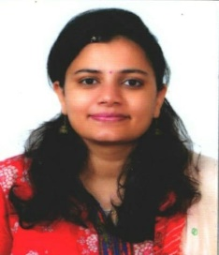
Qualification | M.D (Kayachikitsa), Ph.D (Kayachikitsa)
Designation | Assistant Professor  Department of Kayachikitsa
Registration No.  Name of Board | 13625 ( Board of Ayurvedic & Unani Systems of Medicine , Punjab)
Date and place of Birth | 24-04-1989  Kurukshetra ( Haryana)
Total Teaching Experience | 8 Years
Phone No. | 8105972468
Email | dr.nehasharma24@gmail.com
Address | M.S.M Institute of Ayurveda,  B.P.S Mahila Vishwavidyalaya, Khanpur Kalan, Sonipat, Haryana

