Name | Dr Kapil | 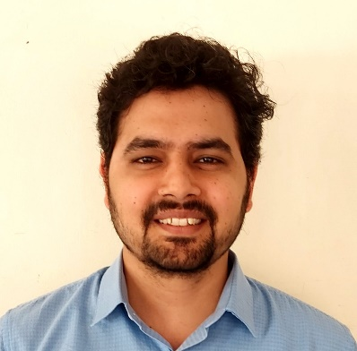
Qualification | M.D. (Kriya Sharir)
Designation | Assistant Professor  Department of Kriya Sharir
Registration No.  Name of Board | 24672,  Council of Indian Medicine, Haryana
Date and  place of Birth | 31/12/1989  Haryana
Total Teaching Experience | 5 Years 9 Months Approx
Phone No. | 8901006644
Email | Kpy3112@gmail.com
Address | M.S.M. Institute of Ayurveda  B.P.S. Mahila Vishwavidyalaya, Khanpur Kalan, Sonipat, Haryana-131305, India

