Name | Dr. Amit Sharma | 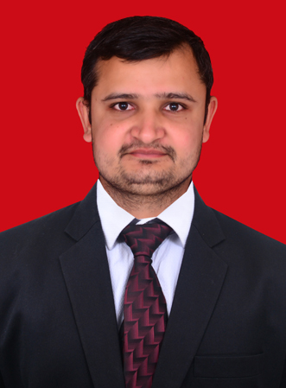
Qualification | M.D.(Dravyaguna),
Designation | Assistant Professor  Department of Dravyaguna Vigyan
Registration No.  Name of Board | 25598 Council of Indian Medicine, Haryana, Panchkula
Date and place of Birth | 15/12/1991 Patli, Gurgaon, Haryana
Total Teaching Experience | 03 Years
Phone No. | +91- 8076005039
Email | AMITAYURVEDACHARYA@GMAIL.COM
Address | F/2/3 Staff Quarter  M.S.M. Institute of Ayurveda  B.P.S. Mahila Vishwavidyalaya, Khanpur Kalan, Sonipat, Haryana, India  Pin Code - 131305

